Rules

Core rules

Standard checks
A standard check is used either to make actions that are against a set difficulty (the target of the action does not react), or as a baseline for the rest of the checks. Remembering something from school is a standard check, so is trying to break an object.
To make a standard check, the player rolls a number of d6, and each 6 is an advance. If the number of advances equals or is higher than the difficulty threshold of the check, the check is successful.
Three things are considered when making a standard check: which attribute is the most appropriate, does the character have an appropriate speciality, and do they have an appropriate mastery.
The number of dices rolled (or the pool of the check) depends on the attribute and the eventual mastery: if one does not have an appropriate mastery, the pool equals the value of the attribute. If one has an appropriate mastery, the pool is instead equal to the attribute value + the mastery value.
If one has an appropriate speciality, then advances are obtained on 5+ instead of only with 6s.

Opposed checks
To make opposed checks is to make a standard check for each character involved. The ones with the most advances is the winner of the check. In case of a draw, either all characters are considered as having won their check.
If, for some reason, the DM clearly wants one clear winner, then the character with the higher mastery wins, if it is still a draw, the highest attribute. If it is still not sufficient to determine a winner, then reroll the check.

Persistent checks
Persistent checks represent actions taken over some time. Characters may roll as is a standard check, but instead of comparing the advances to the difficulty, advances are added to the total number of advances. The check is successful when the total number of advances exceeds the difficulty of the check.
Persistent checks are made to measure the time it takes to get a complex action done by the characters.

Teamwork
If several character work together on the same task, opposed or not, they use the teamwork rule. In this case, one character makes the main check, and the others are supporting.
Each supporting character makes a standard check, and each advance gives an additional dice to the pool of the main check.

Sub-systems

Creating a character
Each attribute starts at 5, and the player may add 1 point in an attribute by subtracting 1 point in another. No attribute may start under 2 or above 8.
The character has at creation 4 specialities. As a guideline, there should be 2 technical specialities related to the character’s role, one knowledge related to that same role, and one related to their hobbies.
Finally, a newly created character should have 5 mastery points, that can be used on any number of masteries.

Investigations and espionage

Concepts
Goal: the question the characters must answer: who is the killer, where are the kidnapped children, is this action espionage or common crime?
Evidence: The elements that give the answer to the goal, with certitude. For instance: the name of the killer, an address that lead to the criminal’s place….
Clues: Elements that may lead characters toward a scene, a character, a piece of evidence, or be exploited. Testimonies, the brand of a car, or some specificity of the murder scene, are some examples of clues. They are the basic ‘bricks’ on which investigations are built.
Links: Some clues may need to be linked to either give another clue, or even to be evidence: if you have a list of suspect, links can be made between it and other clues to cross some names off this list. The brand of a car is of limited use, but if you add a neighbourhood, that may lead you to the murder’s place.
Analysis: Some clues may be investigated further: fingerprints, chemical analysis, geolocation, autopsy… This is often a standard check, that may transform a clue into either another clue, or a piece of evidence.
Scene: a time and place the characters are, and where they may be able to search for clues, either by searching by themselves, or questioning witnesses. Characters may always investigate a scene, and get some answers by the GM about what options they have.

Building an investigation
First step for the GM when building an investigation is to define the goal(s), the main thing during the investigation. This section will be illustrated by a murder at a night club: finding the murder is the goal here. At this point, the GM should also know what are the answers behind the investigation.
Second step is to find which evidence may lead conclusively to the answer. To find the murderer for the example case, you may use their fingerprints or the video evidence of a nearby motel.
Then, you can generate the clues and the links that may lead from the crime scene to the evidence. In our example, we have two different ways to find the murderer, which mean two different path to follow for the players during the investigation. To get the fingerprints, the best thing would be to obtain the weapon used by the murderer, which has been discarded nearby. To find it, the players may want to autopsy the victim’s body to get the ballistic results, then find easily where the killer was, then finally search around. You have several clues here: the weapon (which can be analysed to get the fingerprints), the victim’s body (which can be autopsied to get the ballistic report) and the ballistic reports. To get the camera, you may talk to one witness, which has seen someone running in an alley nearby just after the gunshot. This will then lead to this alley, where one can find a motel has security camera. This information can be used to get a warrant to get access to the tapes, which can be analysed to get some clues about the killer (specific tattoo and vehicle), which can be linked together with a suspect lists to get the killer’s identity.
When you have all of this structure, if some of your clues are not related to a specific scene or character, you may want to do that, possibly by creating new scenes and characters to fit the needs, and the clues that may lead to them.
It is often easier to map the clues, links and evidence in a graph format. To add a bit of complexity to this investigation, some links between the two paths have been added. We have three places for this investigation, and a few characters to create: other investigators, witness, motel owner….
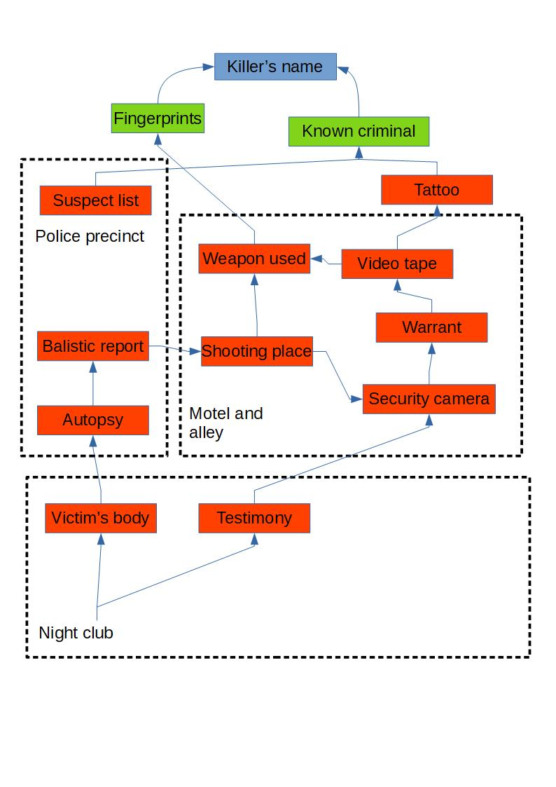

Solving an investigation
Investigating a scene: when arriving at a scene, the GM describes the place and the characters there, and may give the obvious options characters may have at their disposal: what places could be searched, what clues they can create (photo report for example). The GM does not have to give the players all options, but they should have things to do. Some clues are more obvious than others, and should be clearly labelled as such.
Linking clues: when players have several clues available, they may try to link them. The GM chooses what check may be attempted to do so, with a difficulty depending on the challenge of linking what the players have. If the check is a fail, the players may still get some ideas of what type of clue may be missing to them. If the check is successful, the players will get something out of their clues, probably a new one, or the direction toward a scene where they may get some more.
Analysing clues: some clues may need to be analysed to be useful. Sometimes, the PCs may try to do that themselves, to save some time, with the appropriate check. The other option is often to request something from an NPC, which may take some time or cost something. Even when made by an expert, an analysis can still fail, and bring little result, or inconclusive results. In this case, they still may bring partial answer: maybe you don’t get all of the answer, maybe it does not pinpoint a character, but it still eliminates some characters from the possibilities.

Espionage and detection
Espionage is a subset of investigation, which can be divided into intelligence work and counter-intelligence. The common point is not to attract attention, which is measured using the Detection Value (DV), starting at 0.
If the players clearly identify themselves at some point as investigators or agents, the DV automatically goes up by 1.
When characters investigate on a scene, or try to get access to something, enemy characters may attempt a secret check to raise the DV by 1.
Characters may try to lay low for some time, or distract their enemies (with a check), in order to reduce the DV by 1.
Whenever the DV goes up, the GM makes a check, using that value as the pool of the check. The difficulty is determined by the GM, depending on the influence of the opposing organisation on the place: a place strictly controlled by secret police is harder to infiltrate than a new network of agents without much contacts. If this check succeeds, the players are identified as intelligence agents, and various measures may be attempted then: capture them, kill them, or run out of the place not to get captured by them. The specific consequences will of course depend on the context.
Some criminal investigation, especially against organised crime, may use the espionage rules, because such organisations may take drastic measures against investigators, pretty much like an intelligence agency.

Politics and factions
Factions are groups and organizations with unified goals. They may influence the player’s story and they will be influenced by their actions.
The political game may be used to represent gang relationships, hybrid warfare, espionage game or other type of conflicts that may use both violence and negotiations as tools.

Concepts
Faction: A group of people with (most of the time) unified goals, that is able to take actions as a group. Each faction has a reputation, that can be used by its members. A faction has 5 attributes: Personnel, Finance, Security, Research and Production. Their available specialities are the various decisions, and their available masteries are their agents.
Political zone: A political zone is a place or a group that can be influenced or controlled by the factions. For instance, a specific ministry, a city, a specific demographic target…. Zones may be fixed or change during the course of the game.
Decision: A decision is a political action that can be undertaken by various factions.
Agents: An agent is a character that belongs to or work for a faction. They may influence the results of decisions, or be the targets of decisions. Agents of non-player factions are NPCs, and the GM may use any appropriate profile if they have to make a check.
Resources: Resources may be gathered or used by factions to fulfil their goals.

Political turns
In the politic game, turns may be long (sometimes months or even years!). Most of the time, they will not be played consecutively, but rather be a background for the rest of the story. Each turn, each agent may undertake one action for one of their faction (if they have several). The group of players should in general be considered a single agent.
First step of a turn is to determine the effects of the player’s actions since last turn, as well as the actions they have witnessed directly. Player’s actions may kill or create an agent, provide or take resources, or any other effects a decision can obtain.
Second step is for the players to determine the decision they will take. At the same time, the GM chooses the decisions of other agents on the board. Some agents may be secret.
Third and final step is to see the result of the various decisions.

Resources
Each resource may be associated to one or two attributes: Liquidity (associated to Finance), Material (associated to Production and Security), Recruits (associated to Personnel and Security) and Research (associated to Technology).
Most decisions can be facilitated by spending resources. Each resource point spent provides one additional dice for the decision’s check. Some actions may only be facilitated with one type of resource, or only by the resource(s) associated to the selected attribute for the check. The GM may always restrict what types of resources may be used.

Decisions
Develop: The faction tries to obtain a mastery by working to improve its coordination with its agent. It may be obtained with a persistent check with a difficulty of 8. The check may only be facilitated by the associated resource(s).
Direct action: The faction tries to use force to accomplish something: neutralise an agent or deprive an enemy of resources. This is resolved by an opposed check between the attacking faction (using security) and the target. If the target is an agent, it may use their own attributes or their faction’s. In case of success, an agent may be forced to skip its next turn, or the targeted faction looses d6 random resources or 2 selected resources. Only Gear and Personnel may be used to facilitate this decision. An overt direct action cause the faction to loose 1 reputation token (and may have other in-game repercussions), while a covert one causes no loss if it stays covert, or a loss of 2 if the culprit is discovered afterwards. To stay covert requires a check versus the difficulty of the zone where it happens. If a covert action is discovered, one token of the attacking faction is removed (if any was here).
Gather intelligence: the faction tries to get informations on other factions or characters. The decision can try to find a hidden agent (targeting the agent), or get informations on another faction (targeting the faction). Information about a faction may bring either something tied to the scenario, or the number of resources the faction has at the time. This is resolved by an opposed check between the attacking faction and the target. All resources may be used to facilitate this check.
Get resources: the faction will try to get some type of resource, using their capabilities. It is a standard check, with a difficulty depending on the infrastructures of the faction. A success will bring d6 resources of the chosen type. All resources may be used to facilitate this check.
Invest: the faction uses resources to build-up on the long term. The faction makes persistent check with a difficulty equal to the current value of the attribute to upgrade. The persistent check may be continued over next turns, without blocking future decisions. All resources may be used to facilitate this check, but the resource associated to the attribute counts as double.
Networking: the faction tries to build a network of contacts in a zone, which will facilitate further decisions to be taken in this zone. This is a standard check, against the zone’s difficulty. If successful, the faction may add one of its reputation token or, subtract an opponent token.The check may only be facilitated by the associated resource(s).
Optimize: the faction works to get a speciality, by working on its standard procedures. It is a persistent check with a difficulty of 6. All resources may be used to facilitate this check.
Smear campaign: the faction will try to discredit an opposing faction in a zone, which will hamper they ability to conduct future decisions. This is a standard check, against the zone’s difficulty. The check may only be facilitated by the associated resource(s).

Political zones
A zone is mechanically defined by its Difficulty and its traits.
Difficulty represents mostly how hard it is to influence the zone from outside: distrust of strangers, scepticism, important presence of another faction that does not take part in this political game….
Some example of traits are following. As a guideline, a zone may add or subtract 2 to some checks related to the zone or on actions made in it, or generate or subtract 2 resources.
Important media presence: The zone makes it difficult to act covertly. A hidden agent that takes decision on this zone may be spotted if they fail a check against the zone’s difficulty. In addition, the difficulty of the zone counts as being 2 points higher to discover covert actions. Finally, any overt or discovered Direct action in this zone costs 1 more reputation token.
Production reward: The zone may give each turn d6 resource of one type to the faction that has the most of its token there. If several factions have the same number of token, they share equally the gains.
Disillusioned: The difficulty of the zone is considered as 2 higher for the purpose of smear campaigns.
War zone: overt Direct actions do not inflict loss of reputation.

Reputation
Reputation token may be used by the characters belonging to a faction and interacting with the zone to replace of of their attributes for a check by the reputation score. This may be used freely once between each faction turn, any additional use costing 1 token.
In addition, the faction may use its reputation to get +1 dice per token on decisions taking place in the zone.
If one faction should be decreased below 0 reputation token, an opposing faction gets 1 instead.

Making the political game interesting
As a Gm, what you want to do is to create something that drives the PCs.
First idea would be to create defined objectives for the political game: maybe the factions are political parties that need to get reputations before an important election. Maybe the goal is to get an important decision by an authority that does not participate in the political conflict: provide more financial support to the PC’s faction or agree to take an important policy a certain way.
Second point is do not let the political game take too long, except if your players ask for it. It just serves the purpose of giving the player the impression that the world around them evolve depending on their actions and their story.

Combat

Battle zones
The terrain is divided in various zones: a mansion could be divided by wings, by room, or as the GM fancies, really.
Most actions will only target the character’s zone or adjacent zones. The GM may decide if two zones are adjacent or not (depending on obstacles mostly): one may go from one zone to an adjacent one, but not shoot to it, because of an obstacle, and one may be able to shoot from a zone to the next, but no go there, because of another obstacle.

Turn order
PCs and GM alternate turns, beginning by PCs.
Players choose which of their characters goes first, then it’s an NPC’s turn, then the players again, etc. If all players have finished their turns, all remaining NPCs take theirs. If all NPCs have taken their turn, all remaining players may take theirs.
Each turn consists of one action, one movement plus any number of free actions. If there is an abuse of the free action system, the GM is free to cap the number of free actions per turn.
Combat turns have no set duration: a shoot-out in a dark alley make take only a few seconds, while a full scale gun battle may take nearly an hour to resolve.
As a reference, a combat should not get going for more than 6 turns. When the 6th turn ends, one side should either surrender or leave the field to try another solution. This is not a hard rule, but consider it when GMing a combat.

Actions
Each character may take one action per turn, most basic actions are described here:
Progress (movement): the character moves to an adjacent zone.
Flank(movement): the character may ignore an opponent cover
Shoot (action): the character may attack with a ranged weapon. The target may be in their zone or in an adjacent one if the weapon has the long range tag.
Close quarter combat (action): the character attacks a target in their zone with a melee weapon. Melee attack always ignore cover.
Target (action): the character gains a targeting token. During their next ranged attack, if they have a targeting token, they may reroll any 1s on their attack checks.

Attack checks and cover
Attack check are opposed check between the attacker (using the appropriate attributes, speciality and mastery if applicable, depending on their equipment) and the target (same process, depending on their protection equipment).
A targeted character may choose to take cover for their turn. If it is the case, they gain a cover token, that will be lost at the end of their next turn. While they have a cover token, they may reroll all 1s on defensive checks.
Each time a character is targeted, they gain a stress token.

Tags
Offensive and defensive equipment may have some specific capabilities, reflected by their tags:
Ranged (X): this weapon may be used with a shoot action to target characters up to X zones away. If X=0, then it can only be used against character in the same zone. The GM may declare that obstacles block line of sight and reduce the effective range of the weapon.
Melee: The weapon may be used with a Close quarter combat action.
Non-lethal: if a target is put out-of-action by this weapon, it is not dead nor dying, just out of combat. If the character is a PC, it does not have to roll on the Dying Table.
Protection (X): when rolling to defend themselves, the character may replace their mastery by the protection tag of this equipment.
Multiple targets (X): this weapon may be used to attack X targets in the same zone.
Blunt: If the targeted character have Protection(X), they are considered as having twice that amount when they roll to protect against attacks made with this weapon.
Stressful (X): each time the weapon is used, targets gain 1+X stress tokens instead of 1.
Tool (X): when a character uses this equipment for a check, they may add X to their pool of dice.
Precise (X): when the character has a targeting token, they may add X to their pool of dice to attack the target.
Deadly (X): add +X to any damage check inflicted by this weapon.
Group (X): this entity acts like one, but can be affected as X characters.
Movement(X): this allows the character to move X zones with one action.
Load: When this weapon is used, it requires a special loading action to be used again.

Damage and health
When a character is hit by an attack, make a damage check: roll a d6. On 1-2, it is just a scratch and nothing more happens. On 3-5 the character is wounded and out of action. On a 6 or more, the character is dying. Out of action NPCs are often killed immediately.
A wounded character is not in imminent danger, but will require medical attention within d6 hours or suffer complications. If left untreated for another d6 hours, the character is dying. A wounds heals in about a week in normal circumstances, during which the character may not do physical activities.
A dying character requires immediate medical attention, within the next d6 combat rounds in combat, or the next few minutes in narrative time. Even in case of successful medical procedure, the character will probably suffer complications. The character will spend a month resting completely before being considered wounded.
To generate complications, one can roll d6:
- Uneventful: it left a scar, but nothing more serious. The character is lucky, since this complication creates no further issues for them.
- Grievous scars: that one left quite a mark, and an ugly one at that. The character will suffer a penalty of -2 on all checks where the appearance is important.
- Infection/nosocomial infection: the wound has a problem, or the character gets infected by something where they are treated. The wounds takes twice as long to heal.
- Bad injury: this is a wound that will last, and influence the health of the character. All future wounds will take up twice as long to heal.
- Loss of limb: the character has lost an arm or a leg, and will suffer a -2 penalty to any check involving the lost limb.
- Head injury: this wound is severe, and may impede the character’s mental abilities. They will suffer a -2 penalty to all check using logic or knowledge.

Obstacles
When the PCs are facing a task, outside the other sub-systems, that still is a complicated business, it is called an obstacle: searching survivors in the ruins of a building, locating a specific radar blip or trying to convince their client is innocent, for instance. The obstacle must have some kind of tension, otherwise it should just be a persistent check.
An obstacle basically needs a number of successful checks before failing a number of checks.
A simple obstacle would require to succeed in as many checks as the number of PCs, before failing half that number. To increase the difficulty, you can add a few checks to succeed, or subtract a few check they can fail. This last option makes for higher tension, but may significantly increase the odds of failing the obstacle.

Mounts, vehicles and crewed equipment
Mounts and equipment function partially as separate characters (when specifically targeted), and as items (when used by the characters).
In any case, checks should be made using the character’s attributes, specialities and masteries. Some vehicles may provide specific bonus to checks.
If more than one crew member is required, then each character makes the checks related to their role as crew member.
Example 1: A horse gives moves (3) to its rider, as well as deadly (1) to jousting lance.
Example 2: A tank requires 4 crew members: tank commander (Communicates and uses the machine gun), a driver (who maneuvers the tank), a loader and a shooter. The latter will be able to attack with the tank’s main gun, and all characters move at the same time, depending on what the driver does.

